Lightweight Multiband Compressor
Version 1.0.2

Welcome
Thank you for downloading this fine plug-in. Lightweight Multiband Compressor is a dynamic processor VST plugin optimized for low CPU usage maintaining the highest precision in signal processing. With a free adjustable knee it is unique in this class.
In order to get the most out of the Lightweight Multiband Compressor, please spend a few moments reading this brief manual.

License
The pre-compiled Lightweight Multiband Compressor has a very simple license:

- Lightweight Multiband Compressor is freeware. This means that you are free to use this plugin in any context. Also you are free to share it on a personal base (ie. give it to friends). However, only the entire unaltered archive, including this document, may be shared. Public redistribution is only allowed on request.
- Copyright of the code and the pre-compiled plug-in remain property of the Delphi ASIO & VST Project and namely Christian-W. Budde.
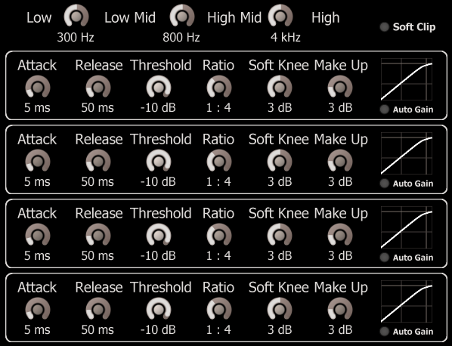
- This plug-in is provided at no cost; therefore the author Christian-W. Budde assume no responsibility for any negative effects that may occur to the end user or the equipment used to run the plug-in.
- Magazine editors are welcome to include the plug-in on cover mount discs or similar media; However, it is mandatory to inform the author Christian-W. Budde about this. A copy of the publication is always appreciated, but not expected.

User Interface
The user interface shows all adjustable parameters and a readout for the characteristic curve. There are no meters available to maintain the lowest possible CPU usage without wasting too much CPU cycles. Either a dedicated analyse plugin or the build in meters can be used for this task.
Here is a commented screenshot:
Soft Clip Limiting
Low Split Freq.
Mid Split Freq.
High Split Freq.
Automatic Make-Up Gain
Soft Knee
(0 dB – 10 dB)
Threshold
(-90 dB - +10 dB)
Attack Time
(10 µs - 1 s)

Release Time
(50 µs - 5 s)
Comp. Ratio
(1:1 – 100:1)
Make-Up Gain
(0 dB – 60 dB)

On top of the plugin the crossover control can be found. Basically 4 bands are available in total, while only the three splitting frequencies between these bands can be adjusted. The possible range depends on the bands beside. The lower bound however is 20 Hz, while the upper band is 20 kHz.
Furthermore a 'Soft Clip' switch can be found.
Below 4 identical compressor stages can be found. These feature the lightweight compressor algorithm that can also be found in the dedicated compressor plugin. On the right of each stage a characteristic plot display can be found.
The dials can be adjusted by clicking and dragging up and down on a dial. To reset the dials to their defaults hold the [Ctrl] key while clicking on the dial. Holding the [Shift] key enters the fine tune mode.
Below any dial a read out shows the exact value of a parameter.
The switches can be toggled by simply clicking the LED or the text.
NOTE: When the plugin is in 'Auto Gain' mode it is not possible to manually adjust the make up gain.

The parameters
This plugin features 32 adjustable parameters in four categories. The categories are 'Crossover' containing the crossover frequencies, 'Time Constants' containing the 'Attack' and 'Release' parameters, 'Characteristic' containing all 'Threshold', 'Ratio', 'Soft Knee' and 'Make Up' parameters and the last category 'Mode' contains the modes 'Soft Clip', 'Mute/Solo/Bypass'.

Crossover
To separate the four bands, three second order linkwitz-riley filters are used per channel. These filters have the properties to maintain a flat frequency response when mixed together.
NOTE: Since Linkwitz-Riley filters are minimum phase filters they do have a group delay and might introduce phasing issues.

Time Constants
The time constants control the detector stage. The attack and release times are responsible for how fast the compressor reacts and how long it takes to recover.

Attack Time
The attack time controls the duration until the compressor reaches 50% of the level determined by the ratio. Internally it is implemented as a simple envelope follower based on a first order filter with a very low frequency (tuned by the attack time). Compared to other manufacturers this time may differ, so take care while comparing this compressor with other compressors.

Release Time
The release time controls the duration until the compressor recovers if the input falls below the threshold. It is implemented identical to the attack stage (see above).

Characteristic
The characteristic curve (as directly shown on the GUI) can be controlled independently by 4 dedicated parameters.

Threshold
The threshold is the level above which compression takes place.
A high value (e.g. -5 dB) means that there is hardly any compression, while a low setting (e.g. -60 dB) means that the signal is nearly compressed all the time.

Ratio
The ratio determines the input/output ratio for signals above the threshold. In this plugin the ratio can be adjusted between 1:1 to 100:1. For example, if the signal is 6 dB above the threshold it will be reduced to only 1 dB above the threshold in case of a 6:1 ratio setting.
If only limiting (ratio of ∞:1) is needed, a special limiter plugin is available in the same series.

Soft Knee
Around the threshold it is sometimes desired to have a slow transition towards the selected ratio. In case of a value above 0 dB the ratio slowly increases if the level increases. Especially for higher ratios the audible change from uncompressed to compressed can be reduced.
The soft knee parameter in dB is the margin below the given threshold. This usually results in a lower level compared to a rather hard knee. This holds especially if the input signal is around the threshold. Keep this in mind when comparing hard vs. soft knee.
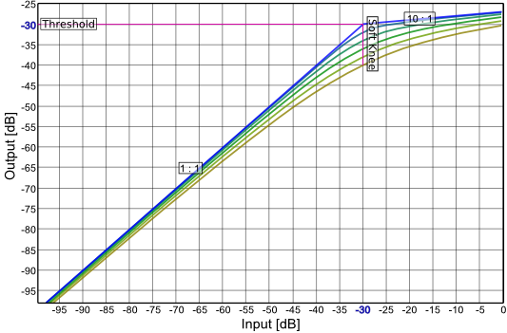

Characteristic Curve Plot

Make Up Gain
To compensate the reduced level, the output level can be adjusted. This gain is called 'Make Up Gain'.
NOTE: Keep in mind that it is not possible to adjust the gain manually if 'Auto Gain' is switched on.

Mode

Limit (Soft Clip)
To ensure the signal stays within its bounds a simple waveshaper is used. The function used here is an approximated hyperbolic tangents.
NOTE: This kind of limiting will add a significant amount of harmonic distortion, since transients can not be passed through uncompressed as without it. Furthermore it is not oversampled which might lead to alias.

Solo/Mute/Bypass
In future versions it will be possible to solo, mute or bypass single bands. It is already implemented on the back-end, but the controls can not yet be found on the GUI.

Feedback / Bug Reports
I am always eager to hear feedback or have bugs reported. The easiest way is to send me a mail to: Christian@aixcoustic.com
Furthermore feel free to download the source code, that can be found in the Delphi ASIO & VST Project at sourceforge.net.

Version History
  - First release!
1.0.2 Renamed 'Fast' to 'Lightweight'

Credits
• Programming: Christian W. Budde
• Additional Framework Programming: Tobias Fleischer, Maik Menz
• Special Thanks: Swen Müller, Duncan Parsons, Laurent de Soras
• Documentation based on a template by Greg Pettit

VST name and technology © Steinberg GmbH
The VST logo is a trademark of Steinberg GmbH

